Synopsis
AF 52
on
Custom LLM for IOFT’s Humanoid Robot
Submitted in partial fulfilment of the requirements of the degree of
Bachelor of Technology
In
Electronics and Computer Science Engineering

by
Smit Patel [EU2237021]
Swikar Patil [EU2237006]
Aaditya Singh [EU1237012]
Ayush Varma [EU2237015]

Under the Guidance of
Mrs. Vishakha Rane
Assistant Professor, EXCS, SJCEM



DEPARTMENT OF ELECTRONICS AND COMPUTER SCIENCE
ST. JOHN COLLEGE OF ENGINEERING & MANAGEMENT
UNIVERSITY OF MUMBAI
2026-2027



Certificate of Approval

This is to certify that Smit Patel, Swikar Patil, Aaditya Singh, and Ayush Varma are bona fide students of the B. Tech program in Electronics and Computer Science Department of St. John College of Engineering and Management, Mumbai. They have satisfactorily completed the requirements of Synopsis as prescribed by ST. JOHN COLLEGE OF ENGINEERING AND MANAGEMENT (An Autonomous College affiliated to University of Mumbai), while working on “Custom LLM for IOFT’s Humanoid Robot”.

Guide Name: Mrs. Vishakha Rane  Signature: | HOD name: Dr.Md.Imaduddin  Signature:

Signature:
Name : Dr. Kamal Shah Principal,
St. John College of Engineering and Management.

Declaration

We declare that this written submission represents our ideas in our own words and where others' ideas or words have been included, we have adequately cited and referenced the original sources. We also declare that we have adhered to all principles of academic honesty and integrity and have not misrepresented or fabricated or falsified any idea/data/fact/source in our submission. We understand that any violation of the above will be cause for disciplinary action by the Institute and can also evoke penal action from the sources which have thus not been properly cited or from whom proper permission has not been taken when needed.

Smit Patel [EU2237021]
Swikar Patil [EU2237006]
Aaditya Singh [EU1237012]
Ayush Varma [EU2237015]

Date:

Acknowledgement
We express our sincere gratitude to all those who have directly and indirectly contributed to the successful preparation of this project synopsis.
We are deeply grateful to Dr. Kamal Shah, Principal, St. John College of Engineering and Management, for providing an excellent academic environment and the necessary facilities to undertake this project.
We extend our heartfelt thanks to the Dr. Md. Imaduddin, Head of the Department of Electronics and computer science Engineering for their constant encouragement, valuable suggestions, and continuous support throughout the preparation of this synopsis.
We would like to express our sincere and heartfelt appreciation to our project guide, Prof. Vishakha Rane, for her invaluable guidance, constructive suggestions, technical expertise, and continuous motivation. Her encouragement and insightful feedback have been instrumental in shaping this project synopsis.
We are especially thankful to our industry mentor, Mr. Rahul Gupta, IOFT, for his valuable guidance, practical insights, and technical support. His expertise and timely suggestions have greatly helped us in understanding real-world requirements and shaping this project.
We also acknowledge all the faculty members and laboratory staff of the Department of Electronics and Computer Science Engineering for their timely assistance, cooperation, and technical support.
Finally, we express our heartfelt gratitude to our parents, family members, friends, and classmates for their constant encouragement, moral support, and cooperation throughout this work.
Group Members
- Smit Patel [EU2237021]
- Swikar Patil [EU2237006]
- Aaditya Singh [EU1237012]
- Ayush Varma [EU2237015]

ABSTRACT

Humanoid and service robots are increasingly being integrated with Artificial Intelligence to enable natural Human-Robot Interaction. Conventional robots generally depend on predefined commands, programmed sequences or dedicated control interfaces. Such systems provide reliable control but have limited flexibility when users want to interact with robots using natural language.

This project presents the IOFT Humanoid Robot Framework, an integrated electronics, embedded systems and Artificial Intelligence platform that combines local Large Language Model reasoning, Retrieval-Augmented Generation and a fail-closed hardware safety mechanism.

The computational system uses Qwen 2.5 3B, deployed locally using Ollama. A Retrieval-Augmented Generation system using ChromaDB provides project-specific knowledge, while MongoDB maintains multi-turn conversation history. A FastAPI backend manages communication between the user interface, AI system and embedded robot controller.
The AI-generated command does not directly control the motors. Instead, it passes through a safety validation layer that checks the tool, parameters, authority mode and telemetry freshness before allowing hardware execution.

The validated command is transmitted through UDP communication to an ESP32, which controls the motors and actuators through appropriate driver circuits. Sensors provide feedback and telemetry to the AI server. A hardware watchdog provides an additional safety mechanism by disabling motor operation when communication is interrupted.
Thus, the project combines embedded electronics, motor control, sensors, wireless communication, local AI, RAG, database systems and software safety to develop a safer and more intuitive intelligent robotic platform.

C O N T E N T S

- List of Figures i
- List of Tables ii
- Abbreviations and symbols iii

Chapter No. | Topic | Page No.
Chapter 1 | Introduction: Background, Problem Statement, Need, Objectives, Scope, Expected Outcomes | 10
Chapter 2 | Introduction, Literature Review Table, Research Gap, Novelty/Innovation | 14
Chapter 3 | Proposed Methodology: Working Principle, Architecture/Block Diagram, DFD Flowchart, Hardware And Software Methodology, Components | 17
Chapter 4 | Project Planning: Wbs, Gantt Chart, Roles, Risk Assessment | 27
Chapter 5 | Resources & Feasibility: Technical/Economic/Operational Feasibility, Budget, Bom | 30
Chapter 6 | Expected Results | 32
Chapter 7 | Sustainability And Impact: Industry Relevance, Societal Impact, Environmental Impact, Sustainable Development Goals | 34
Chapter 8 | Conclusion, References And Appendix | 36

List of Figures

Figure No. | Figure Name | Page No.
Figure 1 | Overall System Architecture | 18
Figure 2 | Hardware Block Diagram | 20
Figure 3 | AI and RAG Architecture | 21
Figure 4 | Level-0 Data Flow Diagram | 21
Figure 5 | Command Safety Flowchart | 22
Figure 6 | ESP32 Motor Control Architecture | 23
Figure 7 | Complete AI-to-Motor Pipeline | 39

Table No. | Title of Table | Page No.
Table 1 | Literature Review And Comparative Analysis | 14-15
Table 2 | Hardware Components And Specifications | 26
Table 3 | Software Components And Technologies | 26
Table 4 | Gantt Chart | 28
Table 5 | Roles And Responsibilities | 29
Table 6 | Risk Assessment | 29
Table 7 | Budget Estimation | 31
Table 8 | Bill Of Materials | 31
Table 9 | Expected System Performance | 33
Table 10 | SDG Mapping | 35
Table 11 | Communication Parameters | 38
List of tables
Abbreviations and symbols

- ML: Machine Learning
- AI: Artificial Intelligence
- TF-IDF: Term Frequency-Inverse Document Frequency
- NLP: Natural Language Processing
- DFD: Data Flow Diagram
- UML: Unified Modeling Language
- CSV: Comma-Separated Values
- UI: User Interface
- PDF: Portable Document Format
- HR: Human Resources
- ETL: Extract, Transform, Load

CHAPTER 1: INTRODUCTION
1.1 Background
The integration of Artificial Intelligence with robotics has created new possibilities for Human-Robot Interaction. Conventional robots generally operate using predefined programs, remote controllers or fixed sequences of commands. Although these methods provide predictable operation, they require the user to understand the robot's control interface.
Large Language Models provide an alternative approach by allowing users to communicate with robotic systems using natural language.
For example, instead of directly controlling a motor through a controller, an operator can provide a high-level instruction. The AI system interprets the instruction, converts it into a structured command and passes the command to the embedded controller.
However, direct connection between an LLM and physical hardware introduces safety problems. An LLM may produce invalid commands, unexpected parameters or commands that do not match the actual hardware configuration.
The proposed project addresses this problem by placing an independent safety validation layer between the AI system and the ESP32 hardware controller.

1.2 PROBLEM STATEMENT
Existing natural-language robotic systems have the following problems:
1. Unconstrained AI Output
An AI model may generate commands or parameters that are not suitable for the physical robot.
2. Lack of Hardware Awareness
A general-purpose language model does not automatically understand the exact motors, sensors, voltage requirements and operating limitations of a particular robot.
3. Communication Failure
Loss of communication between the AI server and embedded controller can cause unsafe or incomplete operation.
4. Lack of Independent Safety Validation
If the LLM itself is responsible for determining whether its own command is safe, an incorrect AI output may reach the hardware.
5. Limited Natural Interaction
Traditional robots generally require specific commands, joysticks or dedicated control interfaces.
Therefore, the proposed project aims to provide natural-language interaction while keeping the AI system separated from direct motor control through an independent validation layer.

1.3 NEED OF THE PROJECT
The project is required because modern robotic systems need both intelligent interaction and reliable hardware control.
The major requirements are:
- Natural-language interaction.
- Local AI processing.
- Low dependence on cloud services.
- Project-specific knowledge retrieval.
- Conversation memory.
- ESP32-based control.
- Motor and actuator control.
- Sensor-based feedback.
- Wireless communication.
- Command validation.
- Watchdog protection.
- Hardware/software integration.
The original project document identifies the requirement for local AI, safety validation and microcontroller-level failsafe protection.

1.4 OBJECTIVES
General Objective
To design and develop an intelligent humanoid robot capable of understanding natural-language instructions using a locally deployed language model and safely converting those instructions into validated commands for embedded hardware.
Specific Objectives
- To develop an ESP32-based embedded robotic control system.
- To interface motors and actuators with the ESP32 using suitable driver circuits.
- To integrate sensors for collecting robot-state information.
- To implement UDP-based communication between the AI server and ESP32.
- To deploy Qwen 2.5 3B locally using Ollama.
- To adapt the LLM for structured robotic tool calling.
- To implement Retrieval-Augmented Generation using ChromaDB.
- To implement conversation memory using MongoDB.
- To develop a FastAPI backend.
- To develop an independent fail-closed safety validation layer.
- To validate AI-generated commands before hardware execution.
- To implement watchdog-based hardware protection.
- To evaluate the complete AI-to-hardware communication pipeline.
These objectives retain the AI, embedded, RAG and safety objectives from the supplied document while removing the mechanical/CAD-specific objectives. The original document specifies ESP32 firmware, Qwen 2.5 3B, RAG, safety validation and experimental validation as the core objectives.

1.5 SCOPE
Hardware Scope
The hardware portion includes:
- ESP32 controller.
- Motors.
- Motor driver.
- Servo/actuator control.
- IMU sensor.
- Ultrasonic sensors.
- Power supply.
- DC-DC buck converters.
- Robot electronic wiring.
- Communication interface.

Software Scope
The software portion includes:
- Qwen 2.5 3B.
- Ollama.
- FastAPI.
- MongoDB.
- ChromaDB.
- Sentence-transformer embeddings.
- RAG.
- Command validation.
- UDP communication.
- Telemetry monitoring.
- Web/VR interface.
The original architecture specifies ESP32 command communication on Port 8888 and telemetry on Port 8889.
Limitations
- The robot is primarily intended for controlled environments.
- Local LLM performance depends on available computing resources.
- The current system does not implement advanced visual SLAM.
- The robot's operation depends on the available motor, actuator and sensor hardware.
- The current safety system validates software commands but does not replace physical safety supervision.
Future Scope
Future improvements can include:
- Depth cameras.
- Computer vision.
- Visual SLAM.
- Better obstacle detection.
- More advanced motor control.
- Additional sensors.
- Improved AI planning.
- More advanced robotic manipulation.

1.6 EXPECTED OUTCOMES
The project is expected to produce:
- A functional intelligent humanoid robot prototype.
- Natural-language interaction.
- Local Qwen 2.5 3B inference.
- RAG-based project knowledge retrieval.
- MongoDB-based conversation memory.
- Structured AI tool calling.
- Independent command validation.
- ESP32-based motor and actuator control.
- Sensor telemetry.
- Watchdog-based protection.
- Safe AI-to-hardware communication.

CHAPTER 2: LITERATURE REVIEW

2.1 INTRODUCTION
The convergence of Artificial Intelligence and robotics has resulted in language-driven robotic systems capable of interpreting high-level human instructions.
Research has explored language-based planning, embodied AI, RAG, efficient LLM fine-tuning and safe robotic control.
However, there is still a requirement for an integrated architecture that combines:
Natural Language → Local LLM → RAG → Memory → Safety Validation → ESP32 → Motor Control → Sensor Feedback

2.2 LITERATURE SURVEY
Table 1: Literature Survey
Paper / Reference | Year | Methodology | Key Finding | Research Gap
SayCan: Grounding Language in Robotic Affordances | 2022 | LLM reasoning combined with robotic affordances | Enables language-based robotic task planning | Does not provide the proposed independent hardware safety gateway
Code as Policies | 2023 | LLM generates robotic control programs | Enables flexible robotic control | Generated code can introduce safety risks
Inner Monologue | 2022 | Uses environment feedback in language-based planning | Improves recovery and task reasoning | Does not provide the complete proposed fail-closed hardware layer
Retrieval-Augmented Generation | 2020 | Retrieves relevant knowledge before generation | Improves knowledge-grounded responses | Original work focuses on NLP rather than embedded robot control
QLoRA | 2023 | Quantized parameter-efficient fine-tuning | Reduces memory requirements | Not specifically designed for robotic command validation
Control Barrier Functions | 2019 | Mathematical safety constraints | Provides formal safety properties | Complex to combine directly with conversational AI
ROS-LLM | 2023 | Language model connected with robotic middleware | Enables language-driven robot actions | Cloud dependency and latency concerns
Bipedal Locomotion using RL | 2021 | Reinforcement learning for locomotion | Improves robotic walking | Does not focus on natural-language interaction
Safe Reinforcement Learning | 2015 | Constrained learning | Reduces unsafe actions | Does not address LLM command validation
Human-Robot Interaction through AR/VR | 2019 | Mixed-reality robotic interaction | Improves operator awareness | Does not combine conversational memory and local LLM

2.3 RESEARCH GAP
Gap 1: Lack of Independent Safety Validation
Many language-driven robots depend on the LLM following instructions correctly. The proposed system introduces an independent safety validator.
Gap 2: Cloud Dependency
Cloud-based models require network connectivity and may introduce latency.
Gap 3: Lack of Project-Specific Knowledge
A general LLM does not automatically know the project's hardware and software configuration. RAG addresses this problem.
Gap 4: Lack of Persistent Conversation
MongoDB allows conversation history to be maintained across interactions.
Gap 5: Lack of Hardware Communication Protection
The ESP32 watchdog provides an additional protection mechanism if communication is interrupted.

2.4 NOVELTY / INNOVATION
The proposed project provides the following innovations:
1. Local AI
Qwen 2.5 3B runs locally instead of depending entirely on cloud APIs.
2. RAG-Based Knowledge
ChromaDB provides project-specific knowledge retrieval.
3. Persistent Memory
MongoDB maintains conversation history.
4. Fail-Closed Safety
Invalid commands are rejected before reaching the robot.
5. Telemetry-Based Validation
Hardware execution depends on valid and sufficiently recent telemetry.
6. ESP32 Watchdog
The embedded controller provides an additional protection mechanism.
7. AI + Embedded Integration
The project integrates:
AI + Software + Electronics + Motors + Sensors + Communication

CHAPTER 3: PROPOSED METHODOLOGY

3.1 PROPOSED SYSTEM
The proposed system consists of three major layers.
Layer 1 — Human Interaction
The user interacts through:
- Web interface
- Voice input
- VR interface
Layer 2 — AI and Software
The local computer contains:
- FastAPI
- Qwen 2.5 3B
- Ollama
- ChromaDB
- MongoDB
- RAG system
- Safety validator
Layer 3 — Embedded Electronics
The ESP32 controls:
- Motors
- Actuators
- Sensors
- PWM signals
- Telemetry
- Watchdog protection

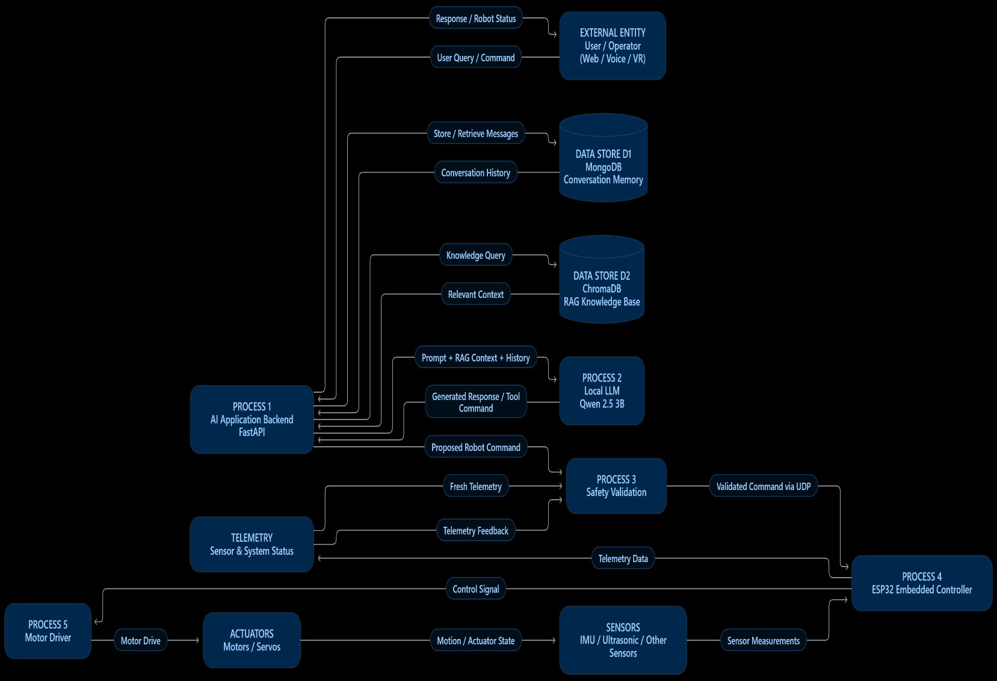
FIGURE 1: OVERALL SYSTEM ARCHITECTURE
Figure 1: Overall System Architecture

3.2 WORKING PRINCIPLE
The system works in the following sequence:
Step 1: User Input
The operator enters a natural-language instruction.

Step 2: Conversation Retrieval
Previous relevant conversation information is retrieved from MongoDB.

Step 3: Knowledge Retrieval
If project-specific information is required, relevant information is retrieved from ChromaDB.

Step 4: AI Processing
Qwen 2.5 3B processes:
System Prompt + Conversation History + RAG Context + User Input

Step 5: Structured Command Generation
The LLM generates a structured command.

Step 6: Safety Validation
The command is checked for:
- Valid tool
- Correct parameters
- Allowed parameter range
- Correct authority
- Valid telemetry

Step 7: UDP Communication
Only after successful validation is the command sent to ESP32.

Step 8: Motor Control
ESP32 processes the command and generates appropriate control signals for the motor driver.

Step 9: Sensor Feedback
Sensors continuously provide robot-state information.

Step 10: Telemetry
Telemetry is transmitted back to the AI server.
The supplied document specifies the same six-stage working principle and UDP packet architecture.

3.3 HARDWARE BLOCK DIAGRAM
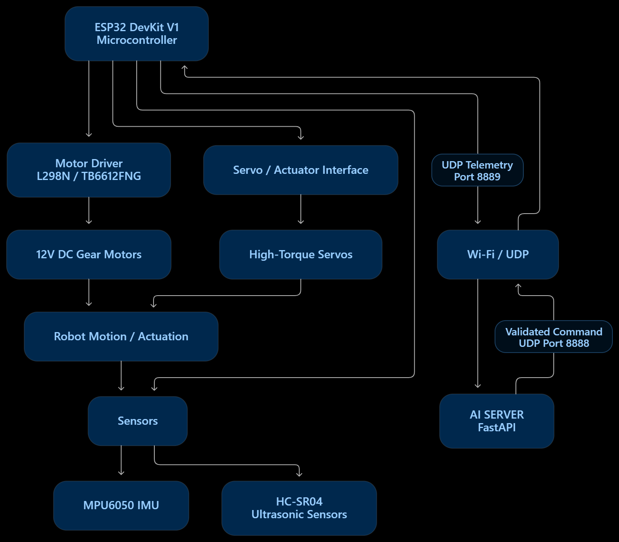

Figure 2: Hardware Block Diagram

3.4 AI + RAG ARCHITECTURE
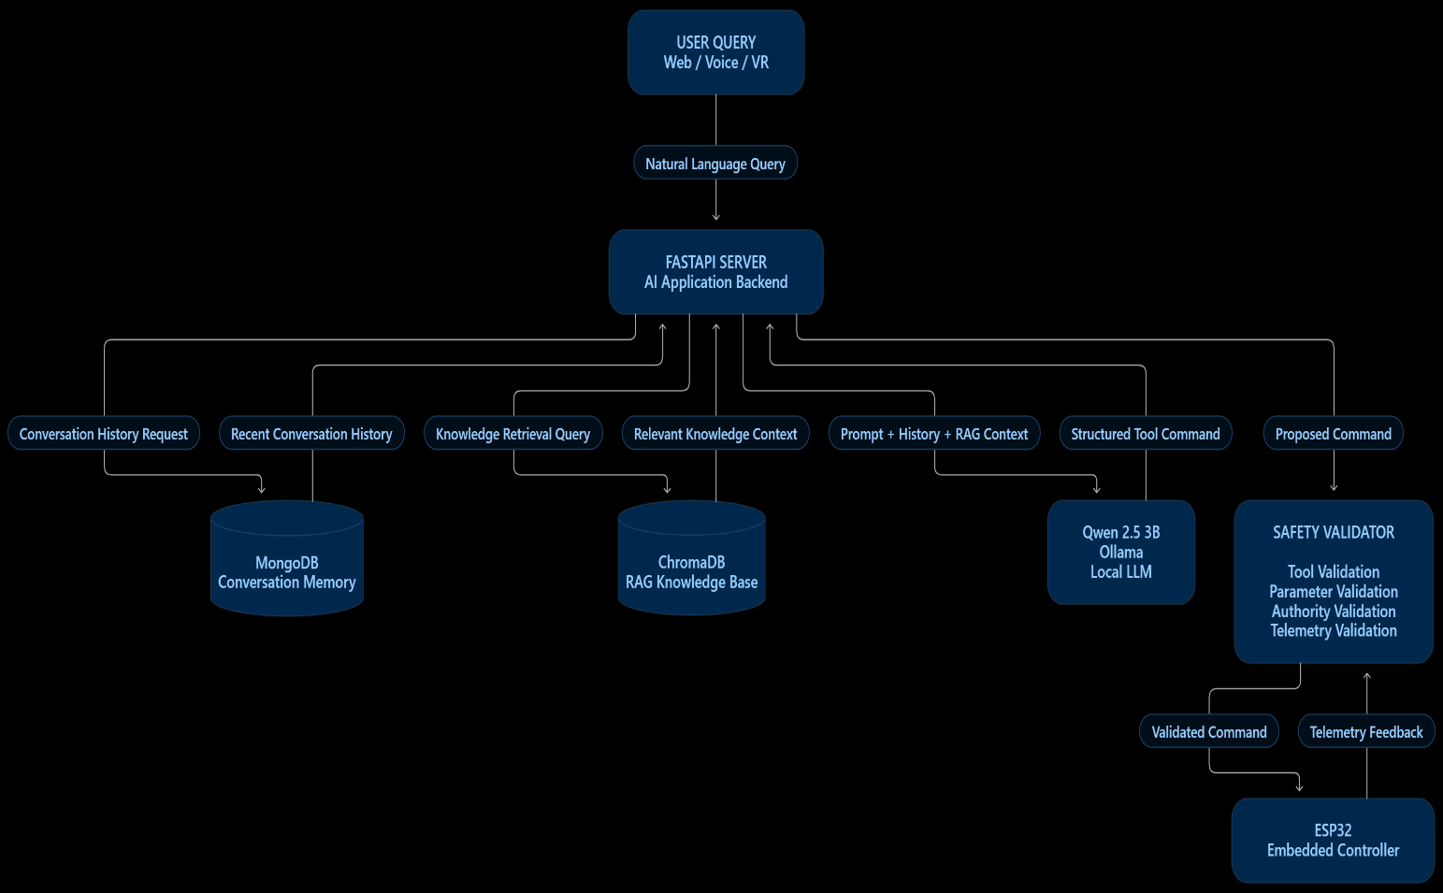

Figure 3: AI, RAG and Conversation Memory Architecture

3.5 DATA FLOW DIAGRAM
Level 0 DFD

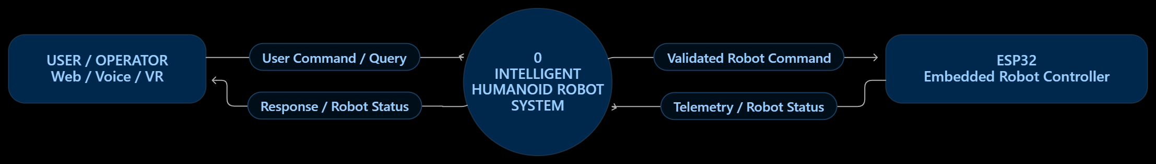

Figure 4: Level-0 Data Flow Diagram

3.6 COMMAND SAFETY FLOWCHART

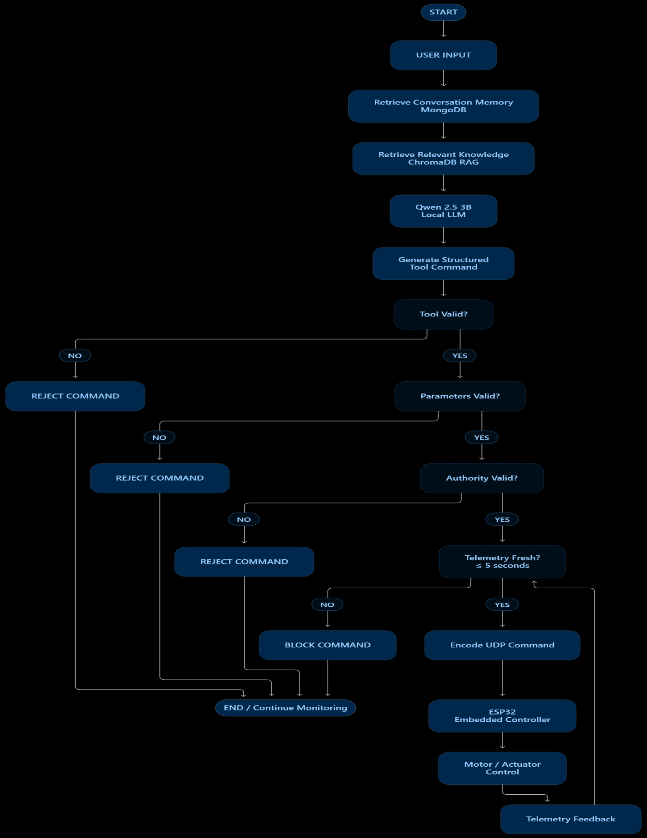
Figure 5: Fail-Closed Safety Validation Flowchart
3.7 MOTOR CONTROL METHODOLOGY

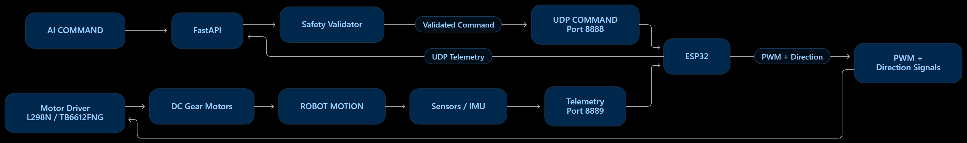

Figure 6: ESP32 Motor Control Architecture

Motor Control Process
- The user provides a natural-language command.
- Qwen 2.5 3B interprets the command.
- The generated command is validated.
- The validated command is converted into a predefined communication format.
- The command is transmitted to the ESP32 through UDP.
- ESP32 receives the command.
- ESP32 generates PWM and direction control signals.
- Motor driver provides the required current to the motor.
- Motor produces the required movement.
- Sensors provide feedback to the ESP32.
- ESP32 sends telemetry to the AI server.
The supplied protocol uses the format:
<COMMAND>|<SPEED_PWM>|<DURATION_SEC>
For example:
FORWARD|20|1.00
and the expected acknowledgement is:
MOTOR_ACK

3.8 SENSOR METHODOLOGY
The project uses sensors to provide information about the physical state of the robot.
MPU6050
The MPU6050 provides:
- Accelerometer data
- Gyroscope data
- Motion information
- Orientation-related telemetry
HC-SR04
The ultrasonic sensor provides:
- Distance measurement
- Obstacle detection
- Forward collision awareness
The supplied component specification lists one MPU6050 and two HC-SR04 sensors.

3.9 SOFTWARE METHODOLOGY
AI Layer
Qwen 2.5 3B
Used for:
- Natural language understanding
- Intent interpretation
- Structured tool calling
- Robot-related reasoning
Model Deployment
Ollama
Used to run the model locally.
RAG Layer
ChromaDB + Sentence Transformers
Used for:
- Document storage
- Embeddings
- Similarity search
- Project-specific knowledge retrieval
Memory Layer
MongoDB
Used for:
- Conversation sessions
- Previous messages
- Context retrieval
Backend
FastAPI
Used for:
- Chat API
- Command API
- Robot state
- Assistant interface
- Communication with the robot
Safety Layer
Used for:
- Tool allowlisting
- Parameter validation
- Authority verification
- Telemetry freshness
- Command rejection

3.10 QLoRA METHODOLOGY
The supplied project specifies QLoRA-based adaptation of Qwen 2.5 3B.
The approach uses quantized model weights and trainable low-rank adapters.
The supplied document specifies:
- Rank: r = 16
- Alpha: α = 32
- Target layers:
  - q_proj
  - k_proj
  - v_proj
  - o_proj
- Training data: over 1,500 domain-specific tool-calling examples.

3.11 COMPONENTS AND MATERIALS
Table 2: Hardware Components
Component | Specification | Quantity | Function
ESP32 DevKit V1 | Dual-core 240 MHz, Wi-Fi | 1 | Main embedded controller
High-Torque Metal Gear Servo | MG996R / RDS3115 | 6 | Actuator control
DC Planetary Gear Motor | 12V High-Torque | 2 | Robot locomotion
Motor Driver | IBT-2 | 1 | Motor direction and PWM control
Battery | 11.1V 3S 2200mAh | 1 | Power source
LM2596 Buck Converter | Adjustable 3A | 2 | Voltage regulation
Robot Chassis | Project-specific structure | 1 Set | Supports electronics and actuators

TABLE 3: SOFTWARE COMPONENTS
Software | Purpose
Python | AI and backend development
FastAPI | Backend API
Ollama | Local LLM deployment
Qwen 2.5 3B | Language reasoning
ChromaDB | Vector database
Sentence Transformers | Text embeddings
MongoDB | Conversation memory
Pydantic | Data and command validation
UDP | Robot communication
ESP32 Firmware | Embedded control

CHAPTER 4: PROJECT PLANNING

4.1 Work Breakdown Structure (WBS)
- Phase 1: Research & Kinematic System Design
  - 1.1 Requirements specification and safety protocol definition
  - 1.2 SolidWorks CAD design of humanoid frame, manipulator linkages, and electronics bays
  - 1.3 Kinematic modeling and joint angular velocity limit derivation
- Phase 2: Embedded Mechatronics & Firmware Development
  - 2.1 ESP32 circuit layout, buck regulation, and hardware breadboarding
  - 2.2 FreeRTOS firmware programming: dual-port UDP listener and 1000 ms watchdog
  - 2.3 Sensor integration (MPU6050 IMU, HC-SR04 ultrasonic) and telemetry packet packing
- Phase 3: AI Engine, RAG & Safety Software Architecture
  - 3.1 FastAPI server implementation, Pydantic schemas, and MongoDB session manager
  - 3.2 ChromaDB vector store configuration with document chunking and embeddings
  - 3.3 Dataset curation and QLoRA fine-tuning of Qwen 2.5 3B for deterministic tool calling
  - 3.4 Authoritative fail-closed validator (CommandSafetyValidator) implementation
- Phase 4: Hardware Assembly, System Integration & Testing
  - 4.1 3D printing of chassis components and physical mechanical assembly
  - 4.2 Network loopback and latency profiling between FastAPI server and ESP32
  - 4.3 End-to-end testing across 266 validation prompts covering boundary violations and recovery

4.2 GANTT CHART
Table 4: Project Planning Schedule (M= month)
Activity | M1 | M2 | M3 | M4 | M5 | M6 | M7 | M8 | M9 | M10 | M11 | M12 | M13
Literature Survey | ✓
Problem Definition | ✓
Hardware Selection | ✓ | ✓
ESP32 Firmware |  | ✓ | ✓
Motor Integration |  | ✓ | ✓
Sensor Integration |  | ✓ | ✓
LLM Dataset Preparation |  |  | ✓ | ✓
QLoRA Fine-Tuning |  |  | ✓ | ✓
RAG Development |  |  | ✓ | ✓
MongoDB Memory |  |  |  | ✓
FastAPI Backend |  |  |  | ✓
Safety Validator |  |  |  | ✓ | ✓
Hardware-Software Integration |  |  |  |  | ✓
Testing |  |  |  |  | ✓ | ✓
Documentation |  |  |  |  |  | ✓
Research Paper |  |  |  |  |  |  | ✓ | ✓ | ✓ | ✓ | ✓ | ✓ | ✓

4.3 ROLES AND RESPONSIBILITIES
Table 5: Team Roles
Student | Role | Responsibilities
Smit Patel | Embedded Systems | ESP32 firmware, motor driver interface, sensors and communication
Swikar Patil | Hardware Integration | Motor/actuator wiring, power system, sensor integration and hardware testing
Aaditya Singh | AI/LLM | Qwen 2.5 3B, Ollama, QLoRA and structured tool calling
Ayush Varma | Software & Safety | FastAPI, RAG, MongoDB, validation and testing

4.4 RISK ASSESSMENT
Table 6: Risk Assessment and Mitigation
Risk | Severity | Likelihood | Mitigation
Invalid AI command | High | Medium | Command validation
Incorrect parameter | High | Medium | Pydantic validation
Motor overload | High | Medium | Parameter and hardware limits
Wireless packet loss | High | Medium | ESP32 watchdog
Telemetry loss | High | Medium | Freshness validation
Power fluctuation | Medium | Medium | Regulated power supply
LLM memory limitation | Medium | Low | Quantized model
Sensor failure | Medium | Medium | Telemetry monitoring
Unexpected AI output | High | Low | Fail-closed rejection

CHAPTER 5: RESOURCES AND FEASIBILITY

5.1 TECHNICAL FEASIBILITY
The project is technically feasible because it uses accessible embedded hardware and open-source software.
The ESP32 provides:
- Dual-core processing
- Wi-Fi communication
- PWM capability
- Embedded control
The software uses:
- Python
- FastAPI
- Qwen 2.5 3B
- Ollama
- ChromaDB
- MongoDB
- Pydantic
The supplied project estimates approximately 3.2 GB VRAM for Qwen 2.5 3B under 4-bit quantization.

5.2 ECONOMIC FEASIBILITY
The system uses open-source software and locally deployed AI.
This reduces dependency on recurring cloud API costs.
The supplied budget estimates the prototype at approximately:
₹12,950

5.3 OPERATIONAL FEASIBILITY
The system is designed so that the operator does not need to directly control individual motor signals.
Instead:
Natural Language ->AI Interpretation ->Command Validation ->ESP32 ->Motor Control
This makes the robot easier to operate and demonstrates the integration of AI with embedded electronics.

5.4 BUDGET ESTIMATION
Table 7: Budget
No. | Component | Quantity | Cost
1 | ESP32 | 1 | ₹550
2 | MG996R Servo | 6 | ₹2,400
3 | DC Planetary Gear Motor | 2 | ₹1,600
4 | Motor Driver | 1 | ₹280
5 | MPU6050 | 1 | ₹220
6 | HC-SR04 | 2 | ₹240
7 | LiPo Battery | 1 | ₹1,850
8 | LM2596 | 2 | ₹260
9 | Printing Material | 2 Spools | ₹2,100
10 | Fasteners/Bearings | 1 Kit | ₹750
11 | PCB/Wires/Terminals | 1 Kit | ₹450
12 | Battery Charger | 1 | ₹750
13 | Miscellaneous | — | ₹1,500
 | TOTAL |  | ₹12,950

5.5 BILL OF MATERIALS
Table 8: BOM
Component | Specification | Quantity | Function
ESP32 | Dual Core 240 MHz | 1 | Controller
MG996R Servo | High torque | 6 | Actuation
DC Gear Motor | 12V high torque | 2 | Locomotion
Motor Driver | IBT-2 | 1 | Motor control
MPU6050 | 6-axis IMU | 1 | Motion sensing
HC-SR04 | Ultrasonic | 2 | Distance sensing
LiPo Battery | 11.1V 2200mAh | 1 | Power
LM2596 | 3A adjustable | 2 | Voltage regulation
Wires/PCB | Prototyping components | 1 Kit | Electrical connections
CHAPTER 6: EXPECTED RESULTS

Expected Result 1 — Command Validation
The system is expected to reject malformed or invalid commands before they reach the ESP32.

Expected Result 2 — Safe Hardware Communication
Only validated commands should be transmitted to the robot.

Expected Result 3 — Local AI Response
The system is expected to provide local AI inference without requiring continuous cloud API access.

Expected Result 4 — RAG Retrieval
The system is expected to retrieve project-specific information from the ChromaDB knowledge base.

Expected Result 5 — Conversation Memory
MongoDB is expected to maintain relevant conversation history.

Expected Result 6 — Telemetry Monitoring
The system is expected to receive robot-state information from the ESP32.

Expected Result 7 — Watchdog Protection
The system is expected to stop motor operation when the communication watchdog condition is triggered.

Expected Result 8 — AI Intent Recognition
The system is expected to correctly identify the user's intended robot operation and convert it into a structured command.

TABLE 9: EXPECTED SYSTEM PERFORMANCE
Parameter | Expected Target
Schema Compliance | 100%
Unexpected UDP Dispatches | 0 during negative tests
AI Response Latency | < 1500 ms target
Telemetry Freshness | ≤ 5 seconds
Watchdog Timeout | 1000 ms
Command Validation | 100% invalid-command rejection
RAG Retrieval | Relevant project context
Conversation Memory | Persistent session-based

CHAPTER 7: SUSTAINABILITY AND IMPACT

7.1 INDUSTRIAL RELEVANCE
The proposed architecture can be extended to:
- Industrial automation
- Automated Guided Vehicles
- Collaborative robots
- Service robots
- Smart laboratory systems
- Educational robotics
- Assistive robotics

7.2 SOCIETAL IMPACT
Natural-language interaction can make robotic systems easier for non-technical users to operate.
Potential applications include:
- Educational robotics
- Assistive systems
- Laboratory automation
- Service robotics
- Human-Robot Interaction

7.3 ENVIRONMENTAL IMPACT
The use of a relatively small locally deployed language model reduces dependence on large cloud-based AI systems.
The project also uses a modular architecture where individual electronic components can be replaced or upgraded without redesigning the complete system.

7.4 Table 10: SDG MAPPING
SDG | Contribution
SDG 3 – Good Health and Well-Being | Potential assistive robotic applications
SDG 7 – Affordable and Clean Energy | Local and optimized computing
SDG 9 – Industry, Innovation and Infrastructure | AI and robotics innovation
SDG 11 – Sustainable Cities and Communities | Intelligent robotic assistance
SDG 12 – Responsible Consumption and Production | Modular and replaceable hardware
SDG 13 – Climate Action | Reduced dependency on large cloud infrastructure

CHAPTER 8: CONCLUSION
Problem Addressed
Traditional robotic systems require predefined commands and interfaces. At the same time, directly connecting generative AI models to physical hardware can create unsafe conditions because of incorrect or unpredictable AI outputs.
Proposed Solution
The proposed IOFT Intelligent Humanoid Robot System combines:
- Local Qwen 2.5 3B language reasoning.
- Ollama for local model deployment.
- ChromaDB-based RAG.
- MongoDB conversation memory.
- FastAPI backend.
- ESP32 embedded controller.
- Motor and actuator control.
- Sensor telemetry.
- UDP communication.
- Fail-closed safety validation.
- Hardware watchdog protection.
The architecture therefore creates a controlled path between natural-language AI and physical hardware:
Expected Contribution
The project demonstrates how Artificial Intelligence, embedded electronics, communication systems and robotic hardware can be integrated into a single platform while maintaining an independent safety layer between AI reasoning and physical actuation.

REFERENCES

- M. Ahn, A. Brohan, N. Brown, Y. Chebotar, O. Cortes, B. David, et al., “Do as I can, not as I say: Grounding language in robotic affordances,” Proc. Conf. Robot Learn. (CoRL), 2022.
- J. Liang, W. Huang, F. Xia, P. Xu, K. Hausman, B. Ichter, et al., “Code as Policies: Language Model Programs for Embodied Control,” Proc. IEEE Int. Conf. Robot. Autom. (ICRA), 2023.
- W. Huang, F. Xia, T. Xiao, H. Chan, J. Liang, P. Florence, et al., “Inner Monologue: Embodied Reasoning through Planning with Language Models,” Proc. Conf. Robot Learn. (CoRL), 2022.
- P. Lewis, E. Perez, A. Piktus, V. Karpukhin, N. Goyal, et al., “Retrieval-Augmented Generation for Knowledge-Intensive NLP Tasks,” Advances in Neural Information Processing Systems, vol. 33, 2020.
- T. Dettmers, A. Pagnoni, A. Holtzman, and L. Zettlemoyer, “QLoRA: Efficient Finetuning of Quantized LLMs,” Advances in Neural Information Processing Systems, vol. 36, 2023.
- A. D. Ames, S. Coogan, M. Egerstedt, G. Notomista, K. Sreenath, and P. Tabuada, “Control Barrier Functions: Theory and Applications,” Proc. European Control Conference, 2019.
- F. Chen et al., “ROS-LLM / Embodied AI related framework,” 2023.
- J. Siekmann et al., “Sim-to-real transfer of blind bipedal locomotion for Cassie on rough terrain,” Proc. IEEE/RSJ Int. Conf. Intell. Robots Syst., 2021.
- J. Garcia and F. Fernandez, “A comprehensive survey on safe reinforcement learning,” Journal of Machine Learning Research, vol. 16, 2015.
- M. Walker, H. Hedayati, J. Lee, and D. Szafir, “Communicating robot motion intent with augmented reality,” Proc. ACM/IEEE Int. Conf. Hum.-Robot Interaction, 2018.
- B. Siciliano, L. Sciavicco, L. Villani, and G. Oriolo, Robotics: Modelling, Planning and Control. Springer.
- J. J. Craig, Introduction to Robotics: Mechanics and Control. Pearson.
- Espressif Systems, ESP32 Technical Reference Manual.
- IEEE, IEEE Standard for Robot Safety, IEEE Std 1872-2015.
- ISO, ISO 13482: Robots and Robotic Devices — Safety Requirements for Personal Care Robots, 2014

APPENDICES
A: ELECTRONICS AND SAFETY PARAMETERS

A.1 Communication Parameters
Parameter | Value
Command Protocol | UDP
ESP32 Command Port | 8888
Telemetry Port | 8889
Watchdog Period | 1000 ms
Telemetry Freshness Timeout | 5.0 s

APPENDIX B: UDP WIRE PROTOCOL
AI Server → ESP32
Format:
<COMMAND>|<SPEED_PWM>|<DURATION_SEC>
Example
FORWARD|20|1.00
Stop
STOP|0|0.00
Expected Acknowledgement
MOTOR_ACK

APPENDIX C: TELEMETRY FORMAT
The ESP32 sends telemetry to the AI server.
Example
{
"roll": 0.12,
"pitch": -0.04,
"yaw": 182.4,
"battery_v": 11.8,
"us_distance_cm": 42.5
}

APPENDIX D: COMPLETE AI-TO-MOTOR PIPELINE
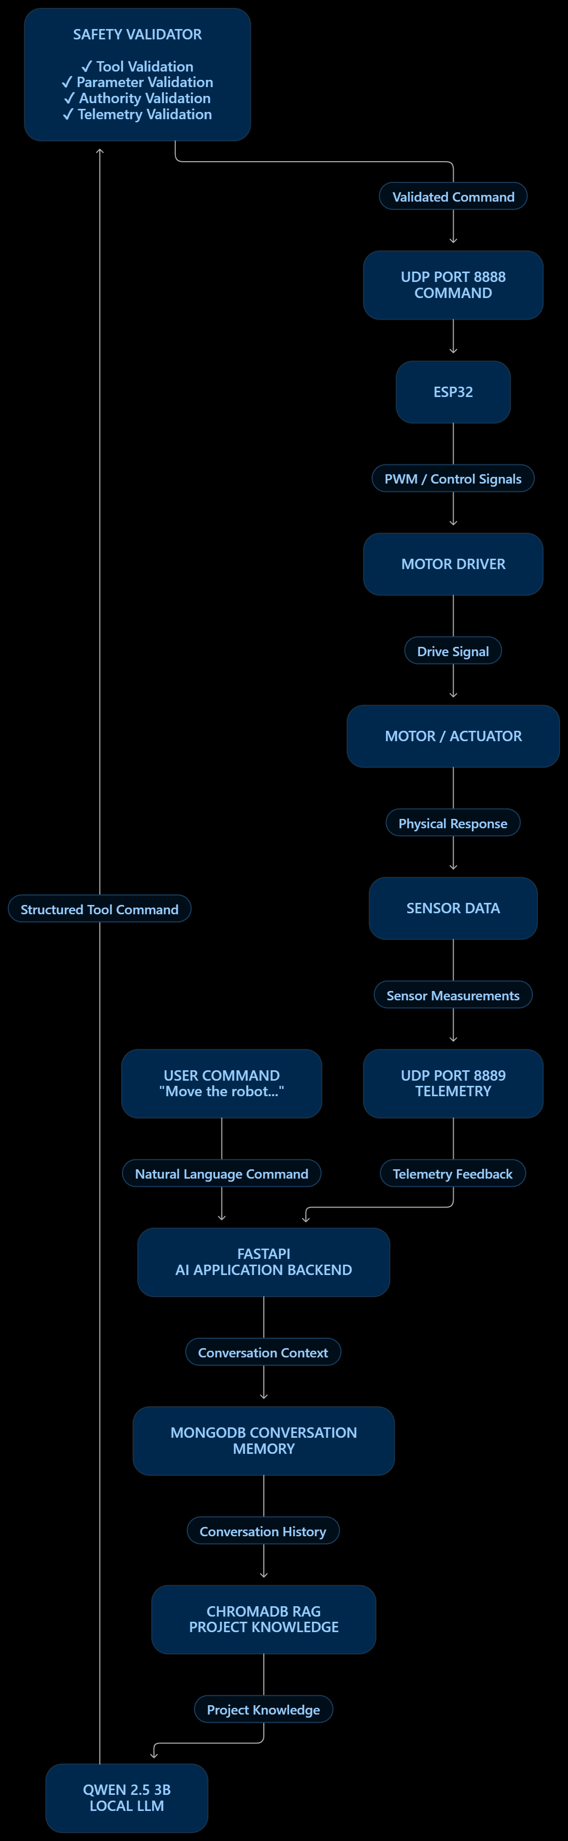
Figure: Complete AI-to-Hardware Closed-Loop Architecture

